**VALUER REPORT UID NO.: CEV/RVO/299/3532/08072024 08.07.2024**

**Form 0- 1 VALUATION REPORT**

**----------------**

**PART – I**

**IMmovable property known as H. NO. 6534, BloCK –G ,AEROCITY, MOHALI, PUNJAB, India-140601 of JOGINDER SINGH ATWALS/O PAKHAR SINGH**

|  |  |
| --- | --- |
| This report is not to be used for any other purpose than specified in the report. | **For Income Tax Purpose Only** |

Valuation certificate ascertaining the Value is based upon the information and data supplied by the owner and my personal inspection. The identification of property/owner is beyond the competency of Valuer. Pursuant to the data supplied for ascertaining the ownership of the above said property, I submit my report as under:

**Brief description of Property**: **The property is a built up house on Ground floor With Mumty on FF on plot measuring land area 220Sqyd. situated at Plot . NO. 6534, BloCK –G ,AEROCITY, MOHALI, PUNJAB, India-140601**

**part - I**

***General:***

1. Purpose for which valuation is made. : For Income Tax Purpose

2. Date as on which valuation is made. : 07.07.2024

3 Name of the owner/owners. : **JOGINDER SINGH ATWALS/O PAKHAR SINGH**

4. If the property is under joint ownership/co-ownership : Single Ownership

share of each such owner Are the shares undivided : Not applicable

5. Brief description of the property: **: H. NO. 6534, BloCK –G ,AEROCITY, MOHALI, PUNJAB, India-140601**

6. Location, : **30.6300289,76.7748741**

Street, Ward No. **H. NO. 6534, BloCK –G ,AEROCITY, MOHALI,**

**PUNJAB, India-140601**

Boundaries of property **: North**-side road, **South**- House No. 6535,

**East**-other house **West**-Front road

7. Survey/Plot No. of land. : House No. 6534

8. Is the property situated in residential/commercial,

mixed area/industrial area. : Residential Area

9. Classification of locality - high class/middle

class/poor class. : Middle class

10. Proximity to civic amenities, like schools,

hospitals, offices, market, cinemas, etc. : Within1-5 Km

11. Means and proximity to surface communication

by which the locality is served. : Road transport

***Land :***

12. Area of land supported by documentary : 220 sqyd.

proof: Shape, dimensions and physical

features.

13. Roads, street or lanes on which the land

is abutting ; Inner Road of block G,Aerocity, Mohali

14. Is it free-hold or lease-hold land ? : Free hold

15. If lease-hold, the name of lessor/lessee, nature

of lease, date of commencement and terms

of renewal of lease: : NA

(i) Initial premium; : NA

(ii) Ground rent payable per annum; : NA

(iii) Unearned increase payable to the :NA

lessor in the event of sale or transfer.

16. Is there any restrictive covenant in regard

to use of land? If so, attach a copy of the

covenant. : NA

17. Are there any agreements of easements ? If so,

attach copies. : NA

18. Does the land fall in an area included in any

Town Planning Plan of Government or any

statutory body? If so, give particulars. : Land falls in area developed by GMADA,Mohali,Pb.

19. Has any contribution been made towards

development or is any demand for such

contribution still outstanding? : NA

20. Has the whole or part of the land been notified

for acquisition by Government or statutory body?

Give date of notification. : Not applicable

21. Attach a dimensioned site plan. : attached

***Improvements :***

22. Attach plans and elevation of all structures

standing on the land and a lay-out plan. : attached

23. Furnish technical details or the building on a

separate sheet. The annexure to this Form may

be used. : **Pl.See annexure - I**

24. (i) Is the building owner-occupied/tenanted/both? : Owner.

(ii) If partly owner-occupied, specify portion and

extent of area under owner-occupation. : NA

25. What is the Floor Space Index Permissible

and percentage actually utilized? : NA

***Rents :***

26. (i) Names of tenants/lessees/licensees, etc. : NA

(ii) Portions in their occupation. : NA

27. Are any of the occupants related to, or

close business associates of the owner? : NA

28. Is separate amount being recovered for the use

of fixtures, like fans, geysers, refrigerator,

cooking ranges, built-in wardrobes, etc.

or for service charges? If so, give details. : NA

29. Give details of water and electricity charges,

if any, to be borne by the owner. : NA

30. Has the tenant to bear the whole or part of the

cost of repairs and maintenance? Give particulars : NA

31. If a lift is installed, who is to bear the

maintenance and operation – owner or tenant? : NA

32. If a pump is installed, who has to bear the cost of

maintenance and operation – owner or tenant? : NA

33. Who has to bear cost of electricity charges for

lighting of common space like entrance hall, stairs,

passages, compound etc. – owner or tenant ? : NA

34. What is the amount of property tax? Who is to

bear it? Give details with documentary proof. : NA

35. Is the building insured? If so give the policy no.,

amount for which it is insured and the annual

premium. : No

36. Is any dispute between landlord and tenant

regarding rent pending in a court of law? : NA

37. Has any standard rent been fixed for the premises

under any law relating to the control of rent? : NA

***Sales :***

38. Give instances of sales of immovable property in : Rate of land as per Collector Rate of Tehsil Mohali

the locality on a separate sheet, indicating the for the year 2018-19(**copy attached)**

name and address of the property, Sale instances not available

registration no.,sale price and area of land sold.

39. Land/ Floor rate adopted in this valuation. : Collector rate of land as in 2018-19 =**Rs. 15200/-**

**per sqyd.**

40 If sale instances are not available or not : Guide Line Rates for the year 2018-19

relied upon, the basis of arriving at the

land rate

***Cost of Construction:***

41. Year of commencement of construction and

year of completion. : Yr. of commencement 2019 and yr. of completion 2020, as stated by the clients

42. What was the method of construction –

by contract, by employing labour directly/both ? : Both

43. For items of work done on contract, produce

copies of agreements. : Details with Owner

44. For items of work done by engaging labour

directly, give basic rates of material and labour

supported by documentary proof. : Details with Owner

**PART –II VALUATION**

|  |  |  |
| --- | --- | --- |
| **SR. NO.** | **ITEMS** | **DETAILS** |
|  | Status | Single ownership |
|  | Date of acquisition | 13.12.2018 as per sale deed no.2018-19/3/1/3925 in the name of Joginder Singh Atwal |
|  | Cost of acquisition of property as on 01.04.2001  **A Land**  I) Extent of land  ii) Unit Market value of land  iii) **Estimated FMV of land as on 13.12.2018 as per guidelines rates of Tehsil Mohali,Pb.**  **B. Value of Building in the year 2020**  i) Plinth area  ii)Replacement rate **according to CPWD Plinth Area Rates For the year 2020**  iii)**Replacement Value as in the year 2020**  iv) Add value of **amenities, Services and extra works** as in 2010:  **Value of Building in the year 2020-21** | 220.00sqyd  **Rs. 15200/- per sqyd as in the yr. 2018 (As per guideline rate of 2018-19, copy attached)**  **220*15200= Rs. 33,44,000/-**  GF=1373.625 sqft. **or 127.61 sqm**  **Rs.16,800/- per sqm**  **(as per CPWD Plinth Area Rates For the year 2020 ,copy attached)**  **Value of building as in 2020-21 = 127.61 * 16800 = 21,43,848 /-**    **Value of amenities, Services and extra works :**  1.Add for internal water supply and sanitary installation @9% of building value as per CPWD=2143848*9% =**Rs. 192946/-**  2. Add for internal electric installation@ 12.5% of building value as per CPWD =2143848*12.5% =**Rs. 267981/-**  3.Compound wall 5.0 ‘ ht. =28 m .*5000/- per r mt. = **Rs. 1,40,000**/-  **Total value of Building = Rs. 27,44,775/-**  **Value of the Building as in 2020-21**  **= Rs. . 27,44,775/-** |

**PART – III DECLARATION**

I hereby declare that -

(a) The information furnished in Part I is true and correct to the best of my knowledge and belief;

(b) I have no direct or indirect interest in the property valued: **H. NO. 6534, BloCK –G ,AEROCITY, MOHALI, PUNJAB, India-140601**

(c) I have personally inspected the property on **08.07.2024**

**Date: 08.07.2024**

**Place: Panchkula Signature of Valuer**

**ANNEXURE - I**

**ANNEXURE-1 TO FORM 0-1**

|  |  |
| --- | --- |
| **Technical Details** | **H. NO. 6534, BloCK –G ,AEROCITY, MOHALI, PUNJAB, India-140601** |

1. No. of Floors and height of each floor ; GF., height = 10’ approx.

2.Plinth area floor wise : **Total covered area on GF- 127.61 sqm** as per sanctioned building plan

.

3. Year of construction : 2020 as stated by client

4. Estimated future life. : 56 years with regular yearly maintenance

5. Type of construction- Load bearing walls/ : Load bearing walls

RCC frame/steel frame

6. Type of foundation : Spread

7. Walls:: 9” thick Brick work in cement sand mortar

a) Basement & Plinth : No

b) Ground floor : Brick work in cement sand mortar

c) Superstructure above ground floor : Brick work in cement sand mortar

8. Partitions : 4.5” thick brick walls in cement sand mortar

9. Doors &Windows( Floor wise ):

a) Ground Floor : Hard wood

10. Flooring ( Floor wise)

a) Ground Floor : Vitrified Tiles flooring,

11. Finishing ( Floor wise):

a) Ground Floor: Cement plaster with synthetic enamel paint over POP

12. Roofing & terracing : RCC slabs & Tile terracing

13. Special architectural or decorative : NIL

features if any

14. (i) Internal wiring-

Surface or conduit : Conduit concealed wiring

(ii) Class of fittings:

Superior/ordinary/poor : Ordinary

15. Sanitary installations:

a) i) No. of water closets : 2 No.

ii) No. of lavatory basins : 2 No.

iii) No. of urinals : Nil

iv) No. of sinks : 2 No. SS

v) No. of bath tubs : Nil

vi) No. of bibets: Nil

vii) No. of geysers : 2 no..

b) Class of fittings:

Superior coloured/superior white/ordinary : superior white

16. Compound wall:

i) Height and Length : As per drawing

ii) Type of construction : 9” thick brick wall in cement sand mortar, plastered & colour washed on both sides

17. No. of lifts and capacity. : Nil

18. Underground Pump- capacity and

type of construction : Nil

19. Overhead tank:

i) where located : Terrace

ii) Capacity : About 2000 Ltr.

iii) Type of construction: : 9” thick brick walls in cement sand mortar duly plastered both sides

and tiles flooring .

20. Pumps- No. & their horse power : No

21. Roads and pavings within the : Anti skid tiles on front and rear yard

Compound approximate area and

Type of paving. : Tiles

22. Sewage disposal- whether connected to : Connected to public sewers.

Public sewers. If septic tanks provided,

No. & capacity

**Signature of registered Valuer**

**PHOTOS OF H. NO. 6534, BloCK –G ,AEROCITY, MOHALI, PUNJAB, India-140601**

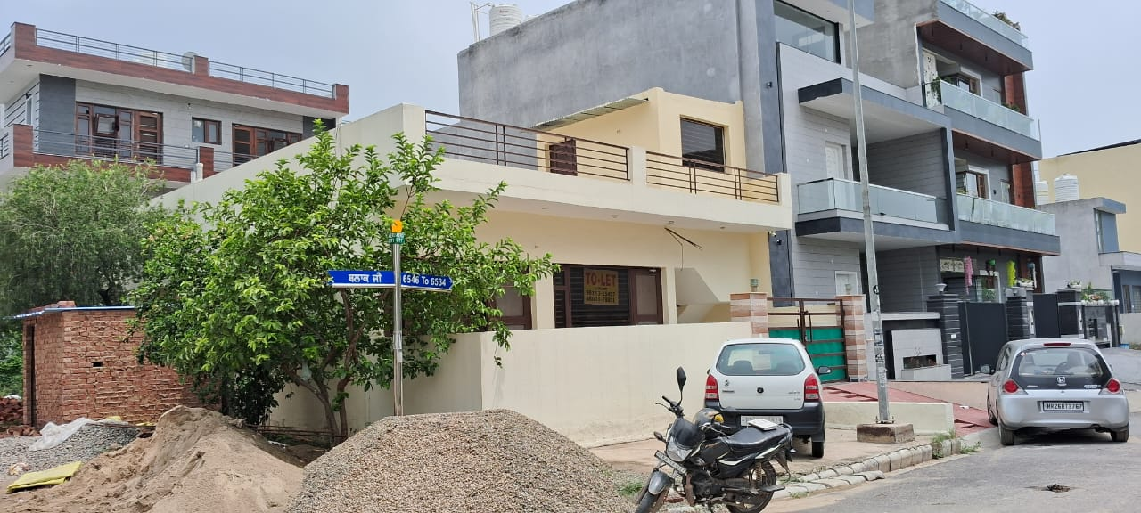 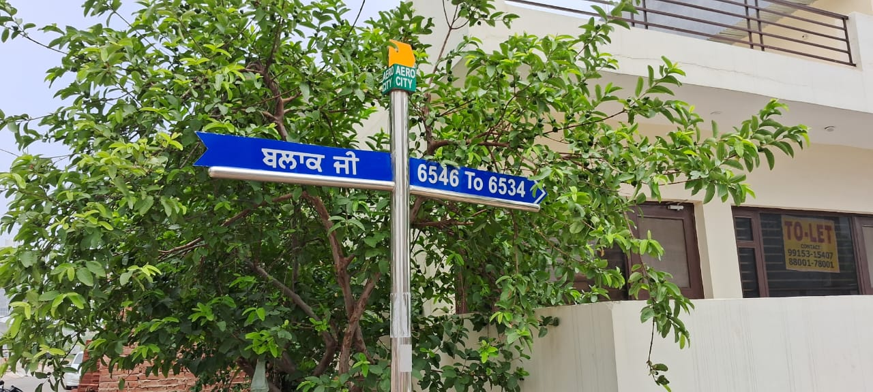

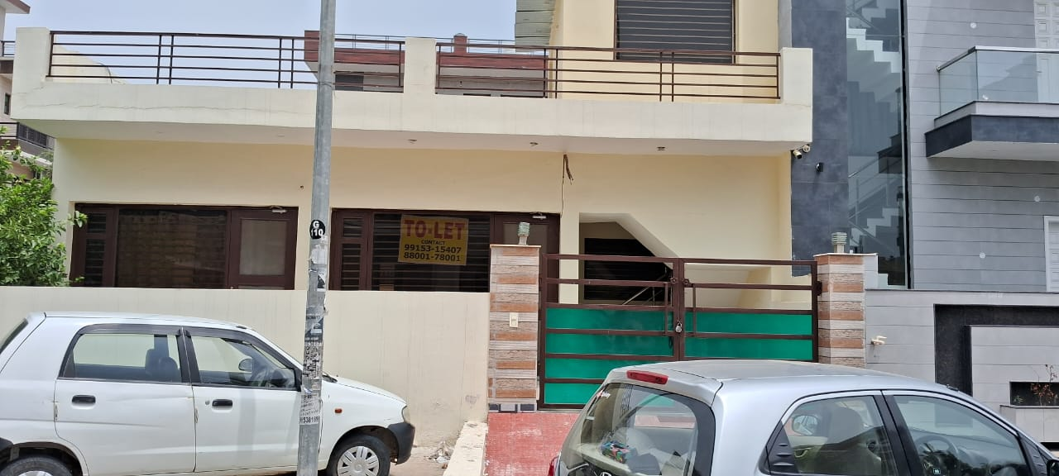 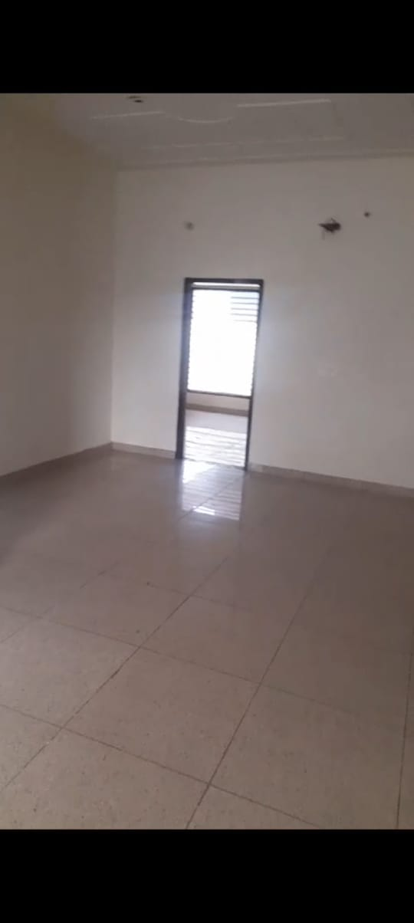

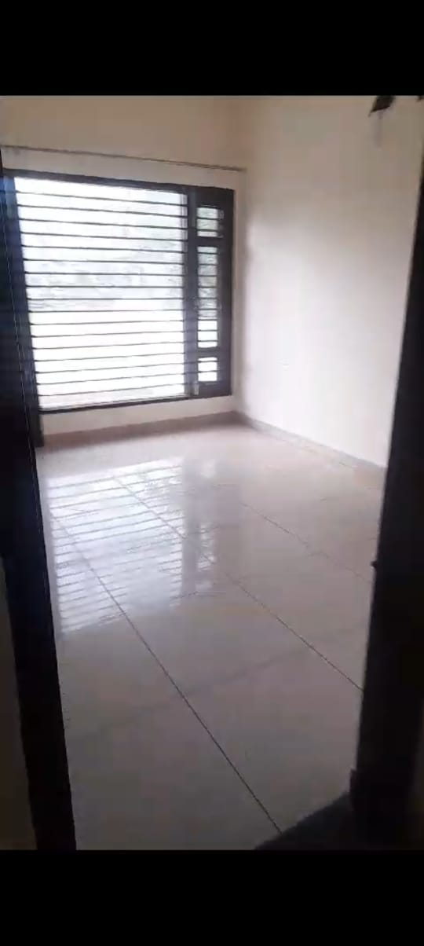 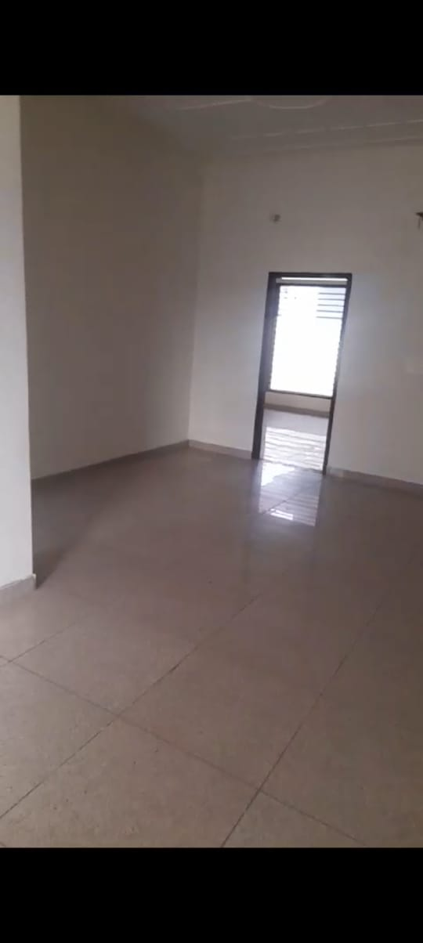 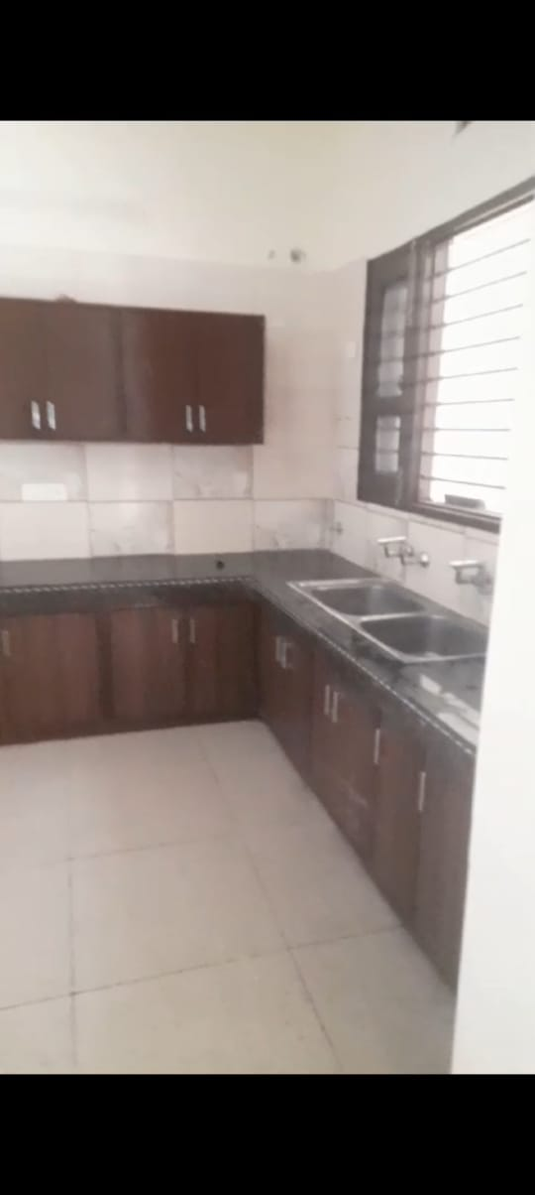 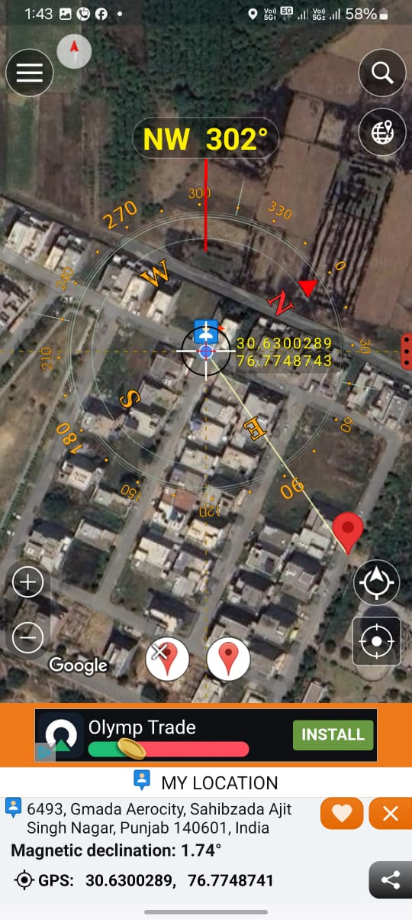

**Google Location**

**Signature of registered Valuer**

**Collector Rates of Tehsil Mohali for the yr. 2018-19**



Signature of registered Valuer

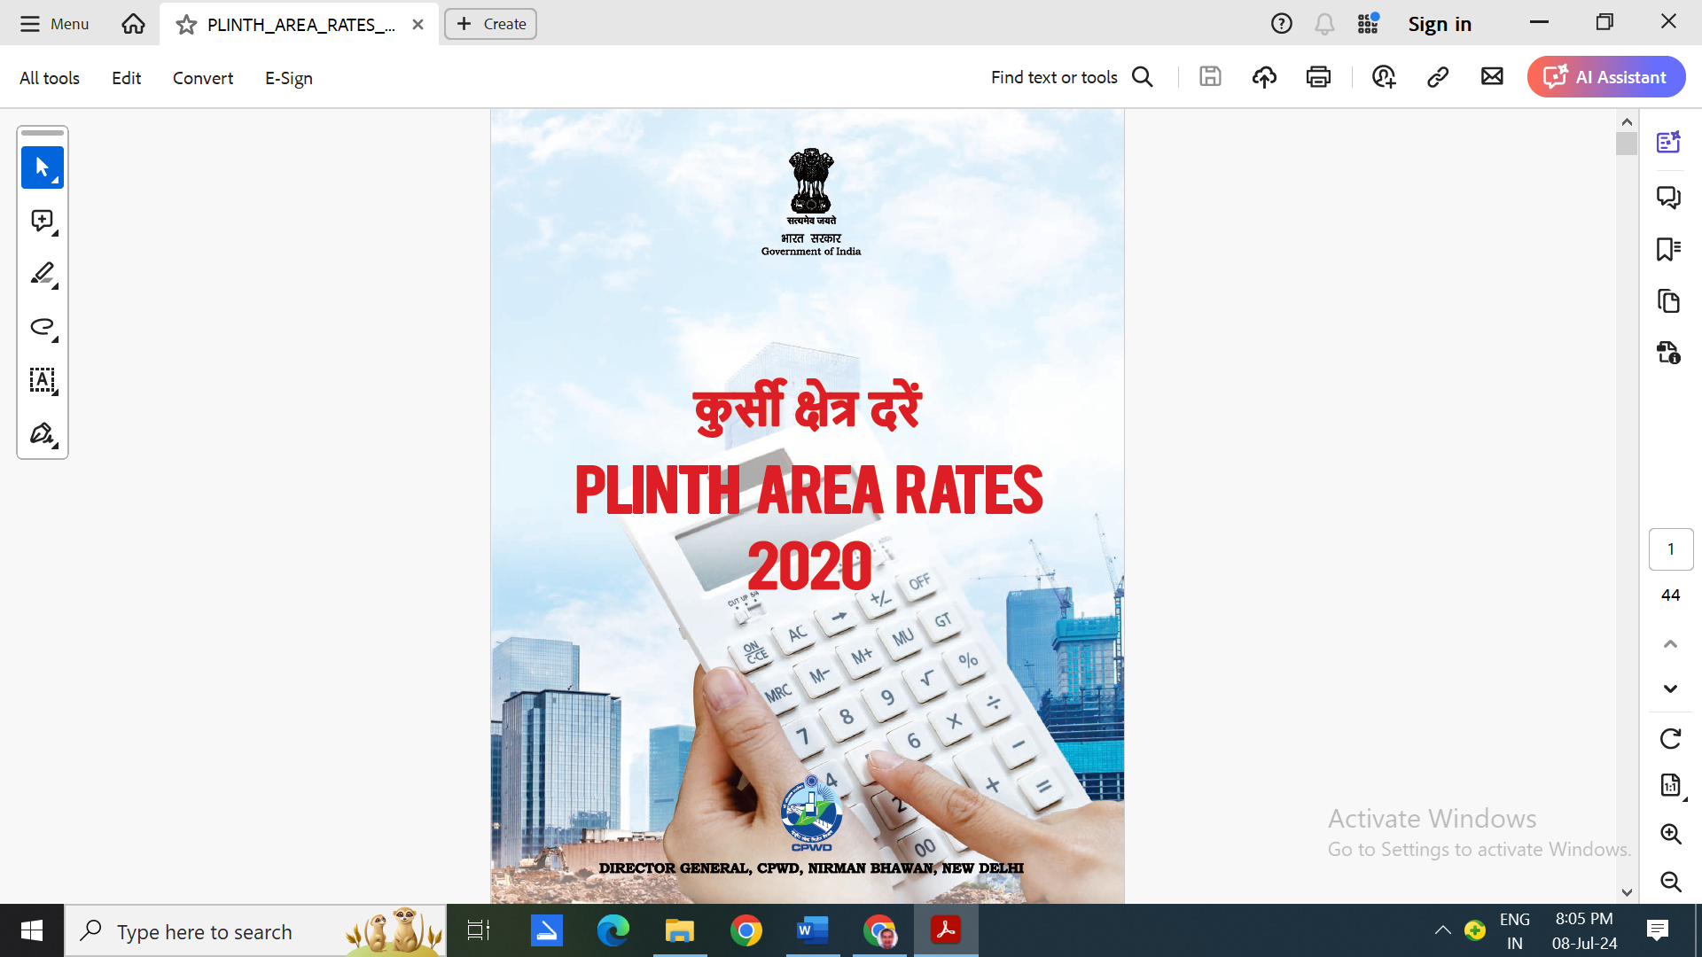

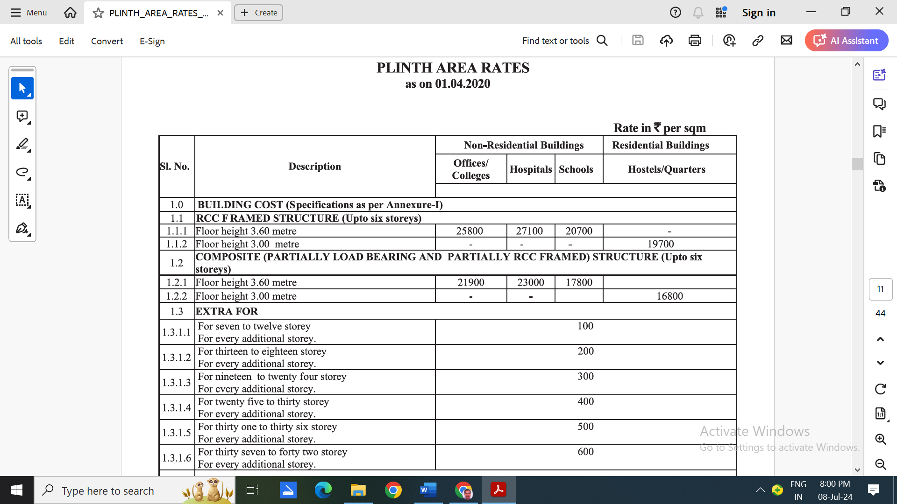

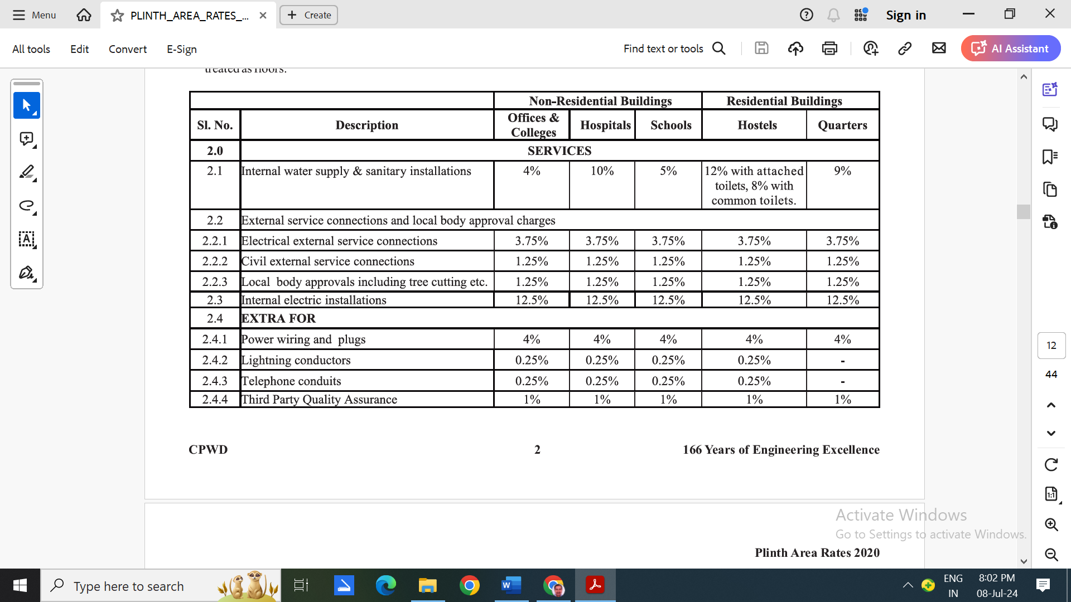

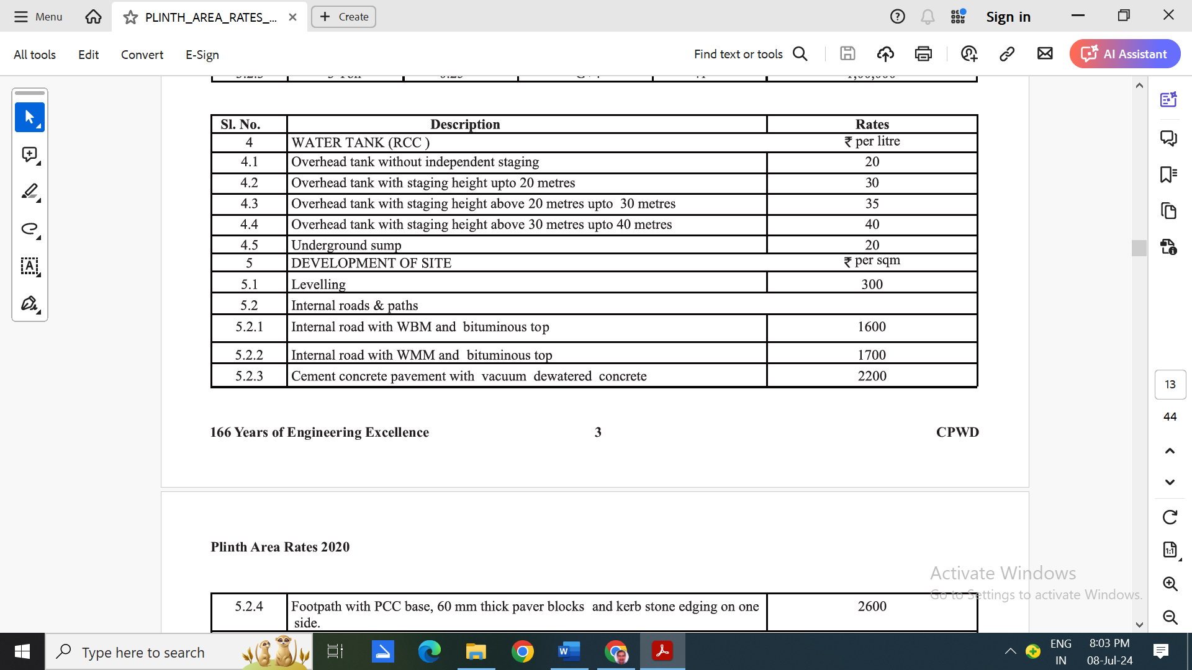

Signature of registered Valuer